**CPSC 24500: Object-Oriented Programming**

**JSlotMachine**

**Due Wednesday, October 25 at 6pm**

In this assignment, you will create a slot machine app. The user interface will look like this:

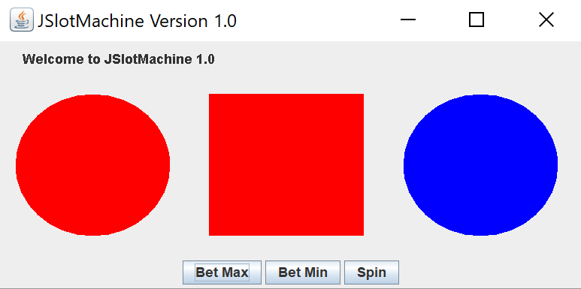

The player starts with a balance of $1.00. If they press "Spin", they bet $0.25. If they press "Bet Max", they wager $0.50. If they press "Bet Min", they wager $0.10. When they press one of these buttons, the arrangement of tiles will randomly change. Each tile will display a red, green, or blue circle or rectangle. When all three tiles show the same shape and color, the player wins what they bet. If the three tiles do not show the same shape and color, the player loses what they bet. The program ends when the player runs out of money.

For example, let's suppose that the player first presses "Spin". This is how the display might look after that first play.

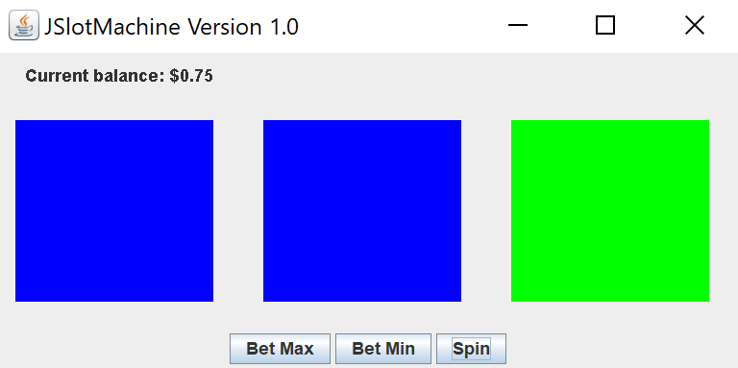

Notice how the player's balance decreased by $0.25, because they did not get all three tiles to match. Now suppose the press the "Bet Min" button. The application might then look like this:

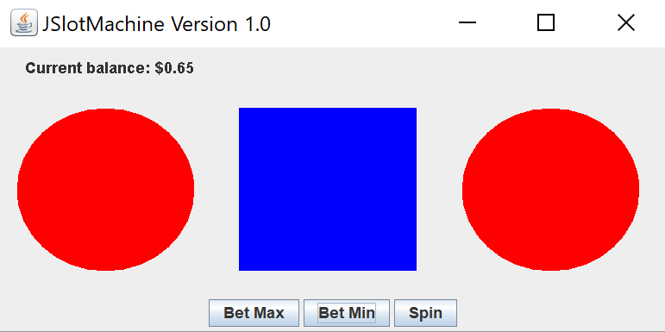

Their balance decreased by another $0.10, because the tiles do not match.

The program ends when the player runs out of money. This is how the program should look at the end.

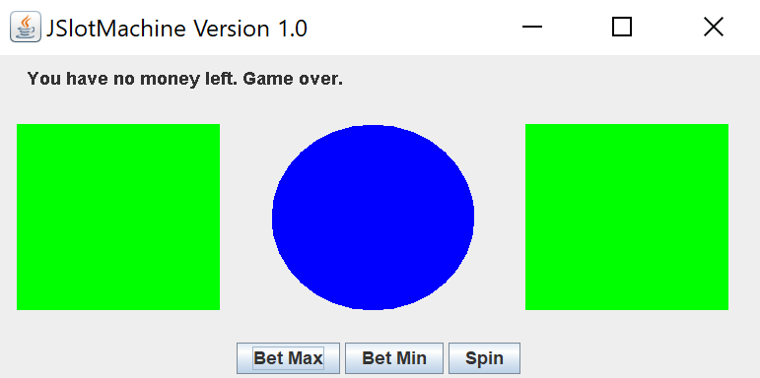

You can work in teams of up to three people on this. However, if you do, you must clearly indicate who wrote which parts of the code. If a team member is not pulling their weight, it is your responsibility to come to me and tell me that.

If you prefer to work alone or circumstances preclude you from working with a partner, you will get an extra 10 percent of your grade added to your grade. For example, if you end up scoring 18 points, you will get a bonus of 1.8 for the extra effort you had to invest because you worked alone.

The program will be graded on the following categories:

* User interface looks like the pictures
* Balance is managed properly, including at the start, in response to wagers, and when it goes negative
* Slots and balance display update when the user presses the buttons
* Code is well-organized and well-documented

Each category will be graded on a 5-point scale, with 5 points awarded for perfect performance in that category and 0 points awarded for complete failure.

Name your program Lastname1LastName2LastName3SlotMachine.java. Make sure you adjust the name of your main class to match so that I can run it.

Make sure you include a comment at the top that indicates who worked on which pieces of the assignment. You need to state this very clearly. If you don't include a comment that clearly identifies what each person did, you will lose 8 points (40%). The reason for this stiff penalty is that, if I don't know who did what, I can't verify that you each contributed meaningfully to the project.

If your code does not compile and run, you will earn 5 points out of 20.

If you copy code from the Internet or from another team, you will earn -20 points out of 20.

As always, ask me or the tutors when you need help.